Machete
Creating a new user account to take orders

Each user of Machete should have their own account. This account identifies who creates an order and who might update an order afterward. In order to take orders, a manager must authorize your account.

To create an account, go to http://machete/account/register

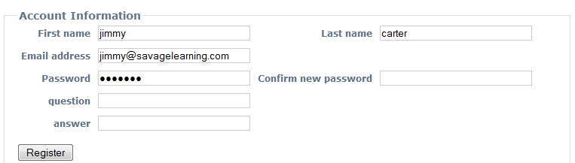

Fill in the information requested and click ‘register’. The information is used to construct your login username. Your first name and your last name become your user name, which you will provide to login to the system.

Your names will be separated by a period, “.” For example, Hilary Stern’s username when she logs in to machete will be: hilary.stern

The other information is for future features:
- The email address will be used to send instructions to reset a password, if you forget it. This is not implemented in the 1.0 release.
- The ‘question’ field is a security question that you can use to reset your password. This is not implemented in the1.0 release.
- The ‘answer’ field is the answer to the security question. This is not implemented in the 1.0 release.

Machete
Assigning roles to new user accounts

Before a volunteer can use Machete to take orders, the volunteer must create an account and a manager must assign the ‘user’ and ‘phonedesk’ roles to the account.

To assign roles, the manager goes to http://machete/account

The page shows a list of user accounts. Click on Edit to change the role settings.

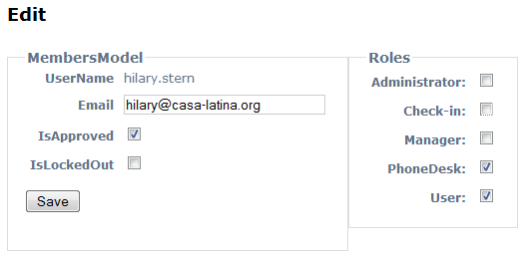

Click on the check boxes next to PhoneDesk and User. The User role allows an account to see information. The PhoneDesk role allows an account to change data.

Click Save. The user will now be able to see and change Employer, WorkOrder, and Assignment records.

